**Project Design Phase-II**

**Data Flow Diagram & User Stories**

|  |  |
| --- | --- |
| Date | 22 October 2022 |
| Team ID | PNT2022TMID19539 |
| Project Name | Project - IoT Based Safety Gadget for Child Safety Monitoring and Notifications. |
| Maximum Marks | 4 Marks |

**Data Flow Diagrams:**

A Data Flow Diagram (DFD) is a traditional visual representation of the information flows within a system. A neat and clear DFD can depict the right amount of the system requirement graphically. It shows how data enters and leaves the system, what changes the information, and where data is stored.

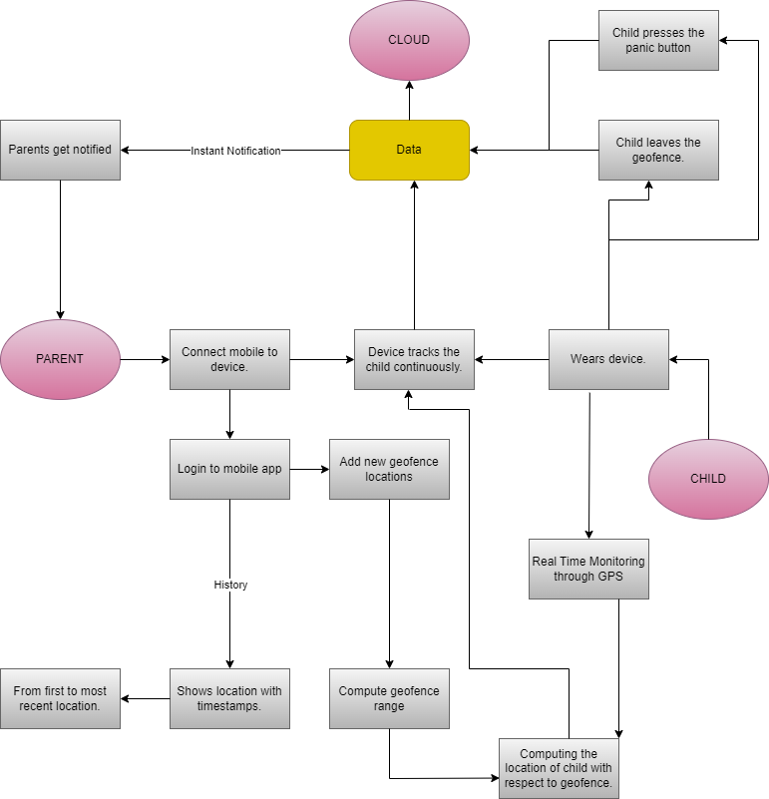

**User Stories**

| **User Type** | **Functional Requirement (Epic)** | **User Story Number** | **User Story / Task** | **Acceptance criteria** | **Priority** | **Release** |
| --- | --- | --- | --- | --- | --- | --- |
| Customer (Mobile user) | Registration | USN-1 | As a user, I can register for the application by entering my email, and password, and confirming my password. | I can access my account / dashboard. | High | Sprint-1 |
|  |  | USN-2 | As a user, I will receive a confirmation email once I have registered for the application | I can receive confirmation email & click confirm, | High | Sprint-1 |
|  |  | USN-3 | As a user, I can register for the application through my Google Account | I can register & access the dashboard with Google Account. | High | Sprint-2 |
|  | Login | USN-4 | As a user, I can log into the application by entering my email & password. |  | High | Sprint-1 |
|  | Dashboard |  | As a user, I can monitor the child ’s location 24/7. |  | High | Sprint-1 |
| Customer Care Executive | Login |  | I can view the working of the application and scan for any glitches and monitor the operation and check if all the users are authorized and provide help to the user is needed. | I can login with my provided credentials. | Medium | Sprint-3 |